Collect Data: Replay Notebooks
Introduction
For the data preprocessing stage of the Auto-Suggest paper, a fully automated data pipeline procedure in containerized environment was implied. By instrumenting a modular pipeline with Apache Airflow and using it’s Celery Executor with Redis as the message broker and a MongoDB database to keep the state of a repository, three dedicated DAGs whith minimal architecture, ensured reproducibility,fault tolerance and scalability in the dataset generation process.
1. Architecture and Orchestration
The core architecture is implemented using the following components:
- Airflow Webserver: Exposes the user interface for DAG control and monitoring.
- Scheduler: Triggers and schedules DAG executions.
- Celery Workers: Run individual Python tasks defined in the DAGs.
- Redis: Serves as the Celery message broker.
- MongoDB: Persists repository metadata and execution results.
- Flower: Provides a real-time dashboard to track Celery worker activity.
These services are, through the Docker Environment interconnected in an isolated network, having only specific network ports exposed to the host server, while also having mounted filesystem directories that are necessary to keep the state of the data.
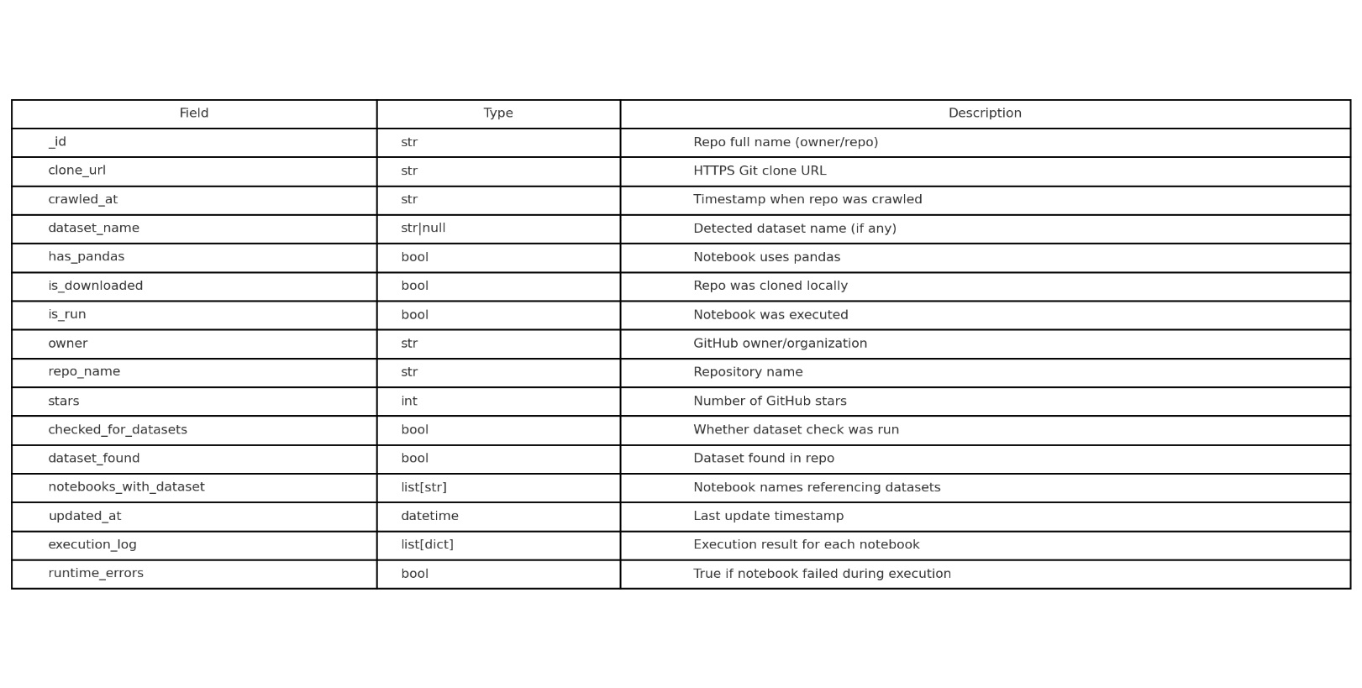Figure 1: MongoDB Schema Table

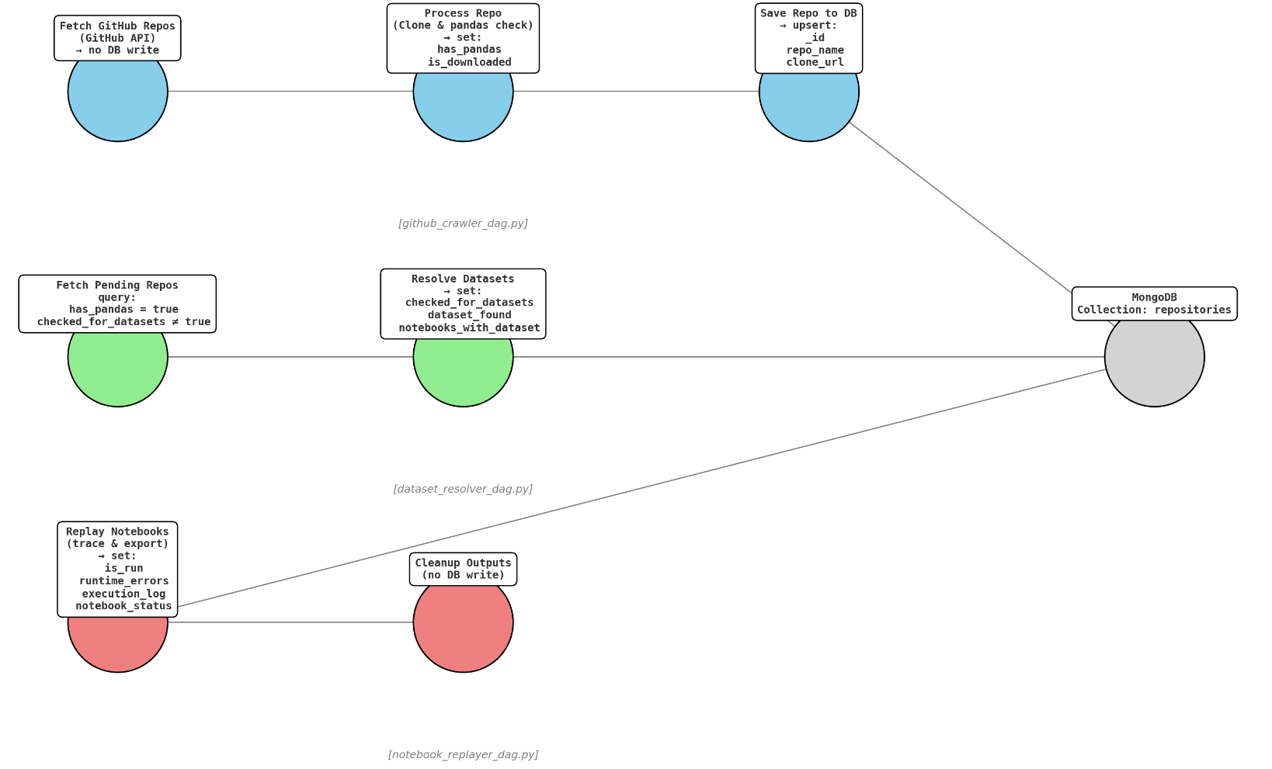
Figure 2: Airflow DAG Flowchart
2. DAG: github_crawler_dag.py
This DAG handles the search and retrieval of candidate repositories:
- It uses GitHub's GraphQL API to find public repositories that match the criteria (“Jupiter Notebooks sorted by stars descending”) and retrieves them.
- It paginates through results and uses a cursor to prevent duplicate downloads across runs.
- It clones the repositories in a temporary directory,checks if repositories have pandas, and if not it deletes them.
- Metadata like repo name, URL, and pandas presence is saved in MongoDB under the repositories collection.
- Debug logs track query cost, remaining API budget, and pagination cursor.
3. DAG: dataset_resolver_dag.py
This DAG ensures that only notebooks that have valid datasets are selected for further processing:
- It recursively searches for data files (.csv, .json, .xls, .parquet)mentioned in the notebooks of each repository in the local directory.
- If a dataset mentioned in a notebook is not found in the repository, then I query is made to the Kaggle API to find it.If a dataset is found, it is downloaded and saved in the same directory of the repository.
- If datasets are found, the dataset_found field is set to true and the repositories for which datasets where found are saved in MongoDB (“notebooks_with_dataset”:[]).
- This flag is used as a condition in the replay stage.
4. DAG: notebook_replayer_dag.py
The final DAG is responsible for replaying Jupyter notebooks so as to parse the Pandas API call sequence and the change of the dataframes, while the Jupyter Notebooks are being runned:
- It queries the MongoDB for repositories where dataset_found == true.
- Notebooks are executed cell-by-cell using a tracing engine.
- Each pandas transformation ("groupby", "merge", "pivot", "pivot_table", "melt", "explode", "drop_duplicates", "sort_values", "dropna", "fillna") is captured.
- For each operator, two files are saved:
  - data.csv: A snapshot of the input/output frames.
  - param.json: A structured JSON describing the parameters.
- MongoDB is updated with:
  - is_run = true if the notebook executes without critical failure.
  - runtime_errors = true if any errors occur during execution.
- Temporary folders are cleaned at the end of each run to prevent disk overflow.

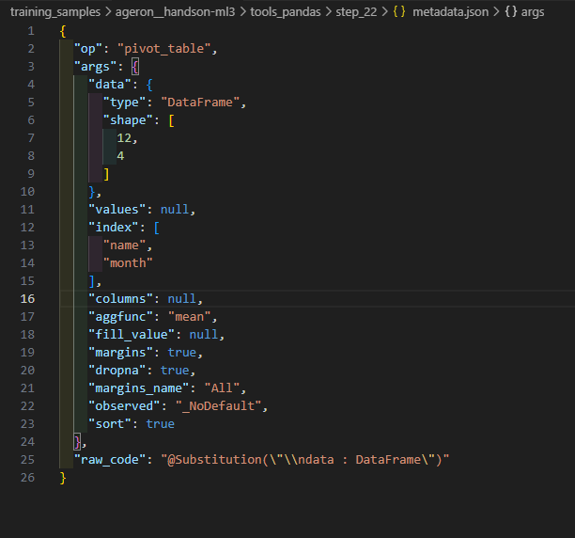
Figure 3: JSON file describing the parameters of a captured Pandas API call

Conclusion
The preprocessing pipeline combines Airflow, Celery, Redis, MongoDB, and custom Python scripts to systematically convert raw GitHub notebooks into structured learning samples. Its modular design and trace-based execution strategy allow high-throughput processing while maintaining complete visibility over data lineage and operator context. This forms the backbone for the Auto-Suggest model training phase.

